**LAKER LURE**

**Newspaper for the students, by the students!**

**CHRISTMAS edition 2022**

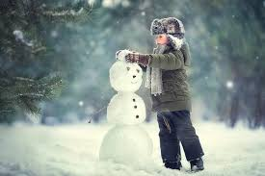

**History of the Snowman**

by Elizabeth Wasik

Have you ever built a snowman before? I bet you have. I personally have always had a fondness for the snow and anything that has to do with it. Have you ever thought about how the classic snowman came to be a symbol of Christmas? The history is actually quite interesting. It all started when it was the middle ages. It was that snowmen were sort of a phenomenon. In 1494 a young artist was tasked with making a snowman for the ruler. 17 years later the city of Brussels made it a cheerful tradition. In the nation of America they used snowmen to act like the guards who left their duties early. It caused the horrific Schenectady Massacre. Sixty villagers were killed during it. After a while the snowman started to gain the whimsical nature that it had once had before the tragedy. Yeah, it is a bit shocking to say the least. Well, I hope you enjoyed my summary of the history of snowmen.

# 

**The Night Before Christmas**

original story by Amora Randolph

It was the night before Christmas when Sally saw an awesome sight. She came down to set up a trap to catch Santa, but he came earlier than usual. She didn’t want to get caught so she went up to her room. There was a vent in her room so she could see in the living room. As she was watching him she didn't notice he was watching her. So, she kept watching the presents he put under the tree. She was still watching him up until he left, but when she fell asleep he went up stairs and gave her the heart pendant that she had wanted for years and left it on her night stand. She told this story to her kids and her grandkids.

**The End**

# 

# **Treble Clef And Bass Clef**

# 

# **by** [James Snyder](mailto:4111jsnyd16@wilsoncsd.org)

*Music can be found in everyday life, commercial jingles, notifications, Tiktok, radio, and many other places. You can find people whistling songs you might know or hear your favorite song at a grocery store. Music dates back to 300,000 BCE when humans started clapping to make rhythmic beats. Then they started the first instrument when they realized hitting sticks together doesn't hurt as much. I interviewed 4 people who are in the band to see how and why they joined the band.*

***_________________________________________________________***

***Mikailia Akers***

**Why do you play the flute?**

I play the flute because I was forced to, even though I really wanted to play the trumpet.

**What was it like when you played the flute for the first time?**

I was pretty nervous the first time, but as I practiced more I became better and more comfortable with this instrument.

**How long have you been playing the flute?**

I have been playing for two years.

**Finally, do you do chorus?**

Yes.

***____________________________________________________________________***

***Grace Wills***

**Why do you play saxophone?**

Okay, so when I was younger, I always wanted to play the clarinet and then my mom told me about the saxophone and I was connected to it.

**What was it like first playing it?**

I was not very good at first, but Ms. Mercurio helped me and she said I had a great sound and all I had to do was learn the fingering and I caught on pretty quickly.

**How long have you been playing?**

I've been playing since 4th grade.

**Finally, do you do chorus?**

Yes.

***___________________________________________________________________***

***___________________________________________________________________***

***Cora Everest***

**Why do you play Trombone?**

Because my sister used to play trombone.

**What was it like when you first played it?**

Difficult.

**How long have you been playing it?**

3 + 1/2 years.

**Finally, do you do chorus?**

Yes ***__________________________________________________________***

***Mrs. Birkman***

**What made you start playing music?**

When I was a kid I always wanted to play an instrument. So I started taking lessons in third grade. Saxophone was my first instrument. I had a fun music teacher who really was kind of inspiring. I kept going through the years of school with music. I've made a lot of good friends, and really enjoyed learning lots of different instruments through middle and high school.

**What instrument do you like to play the most?**

I think I like to play the clarinet the most, because I majored in it in college and to be honest that's the instrument that I wanted to start on as a kid because of Squidward. I want to be better than Squidward, but I couldn't get the sound out of anything except the saxophone so that's what I started on. But I like to play saxophone and clarinet. They're both the instruments that I like to pick up the most.

**When did you start teaching?**

When I was a senior in high school I started giving private lessons to a handful of students. 5 years later I started teaching as a substitute teacher for a band. Then, a year later I started full time teaching.

5 years later, I started teaching at this School!

**What don’t you like about band?**

That’s a tough question… I’m not sure! I love teaching music and helping students learn how to play their instruments. I think hearing notes played out of tune might be my least favorite part….

**The Morgan Horse**

**by Morgan Boyer**

The Morgan horse is a strong, gentle, and willing horse. They really deserve some respect. Morgans are great around kids, adults, and all ages. Also, they are great for beginner riders and various kinds of riding.

People don't really know the ancestry of the Morgan horse; people think there is Welsh cob/ thoroughbred and Native American of Iberian/Oriental strain are in their blood. The founding father of the Morgan we Know is Figure. Where the Morgan gets its name from is from a school teacher that bought him. The name of the teacher is Justin Morgan. Morgan is very special to me in a few ways. One is that Morgan is my favorite horse and also it is my first name. Another way it is special to me is the way it looks and acts. I love Morgans.

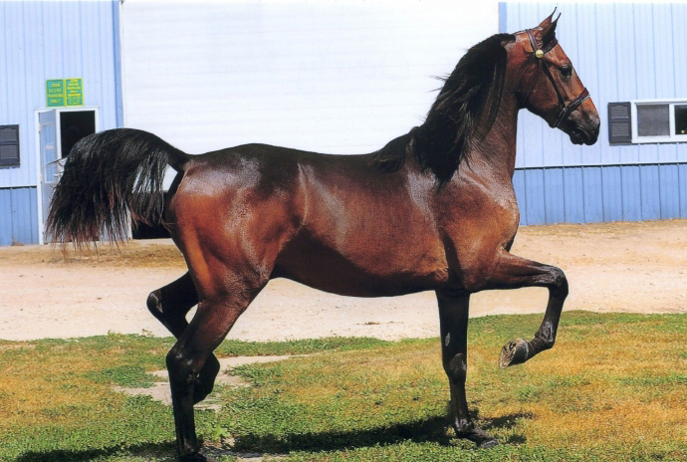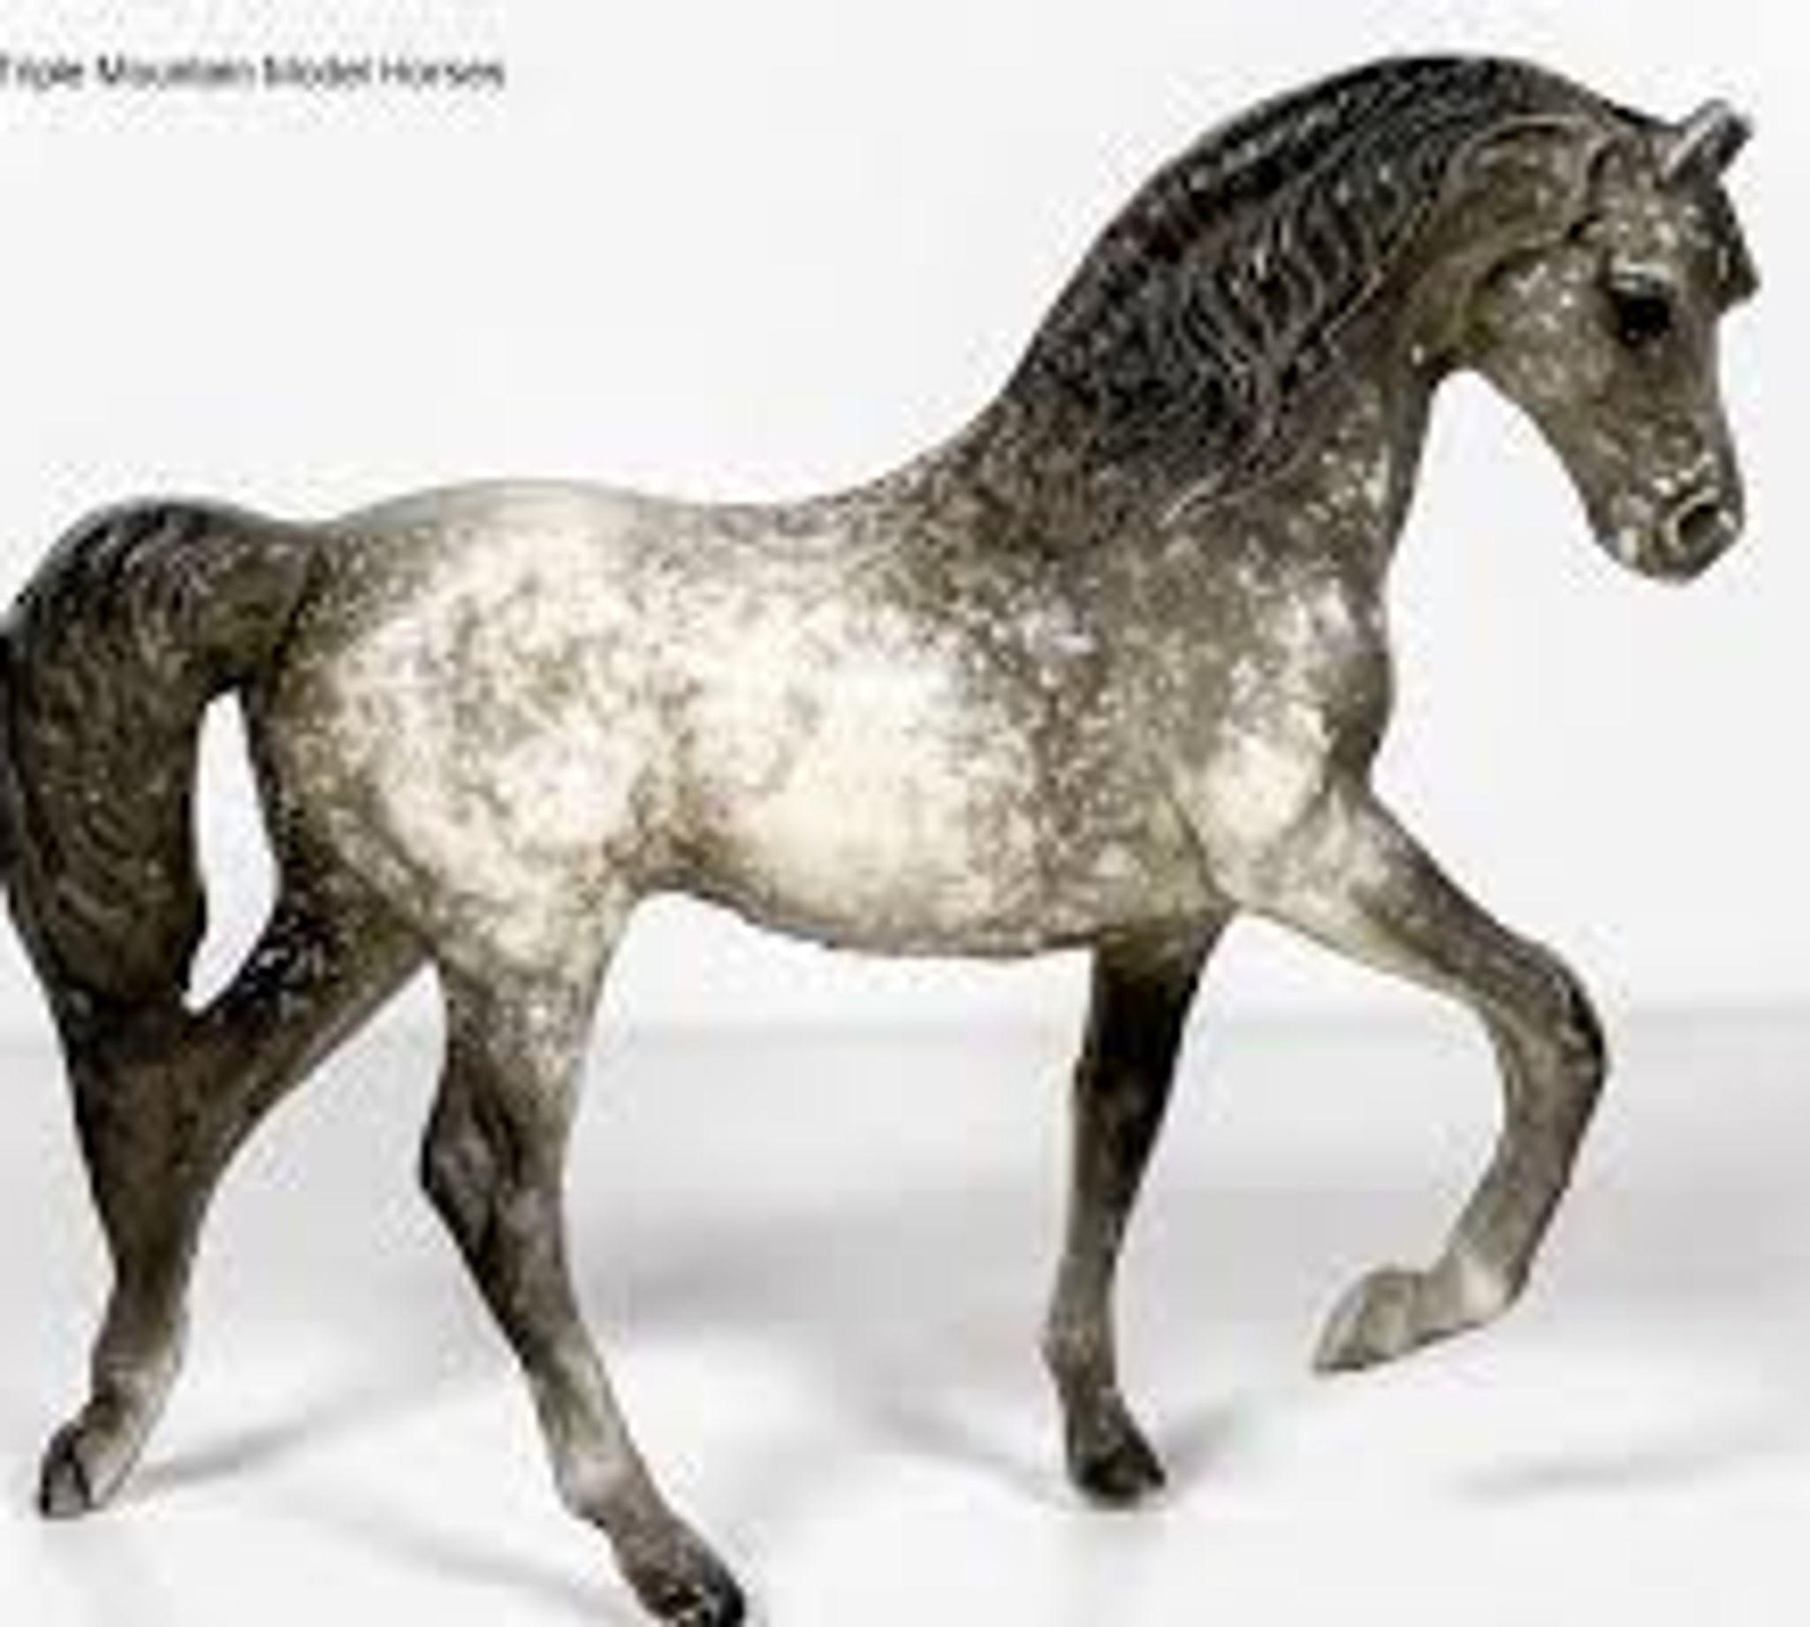

**A dapple gray Morgan the brand of the toy/sculpture is breyer**

**Adapted by The Illustrated Encyclopedia of Horse Breeds**

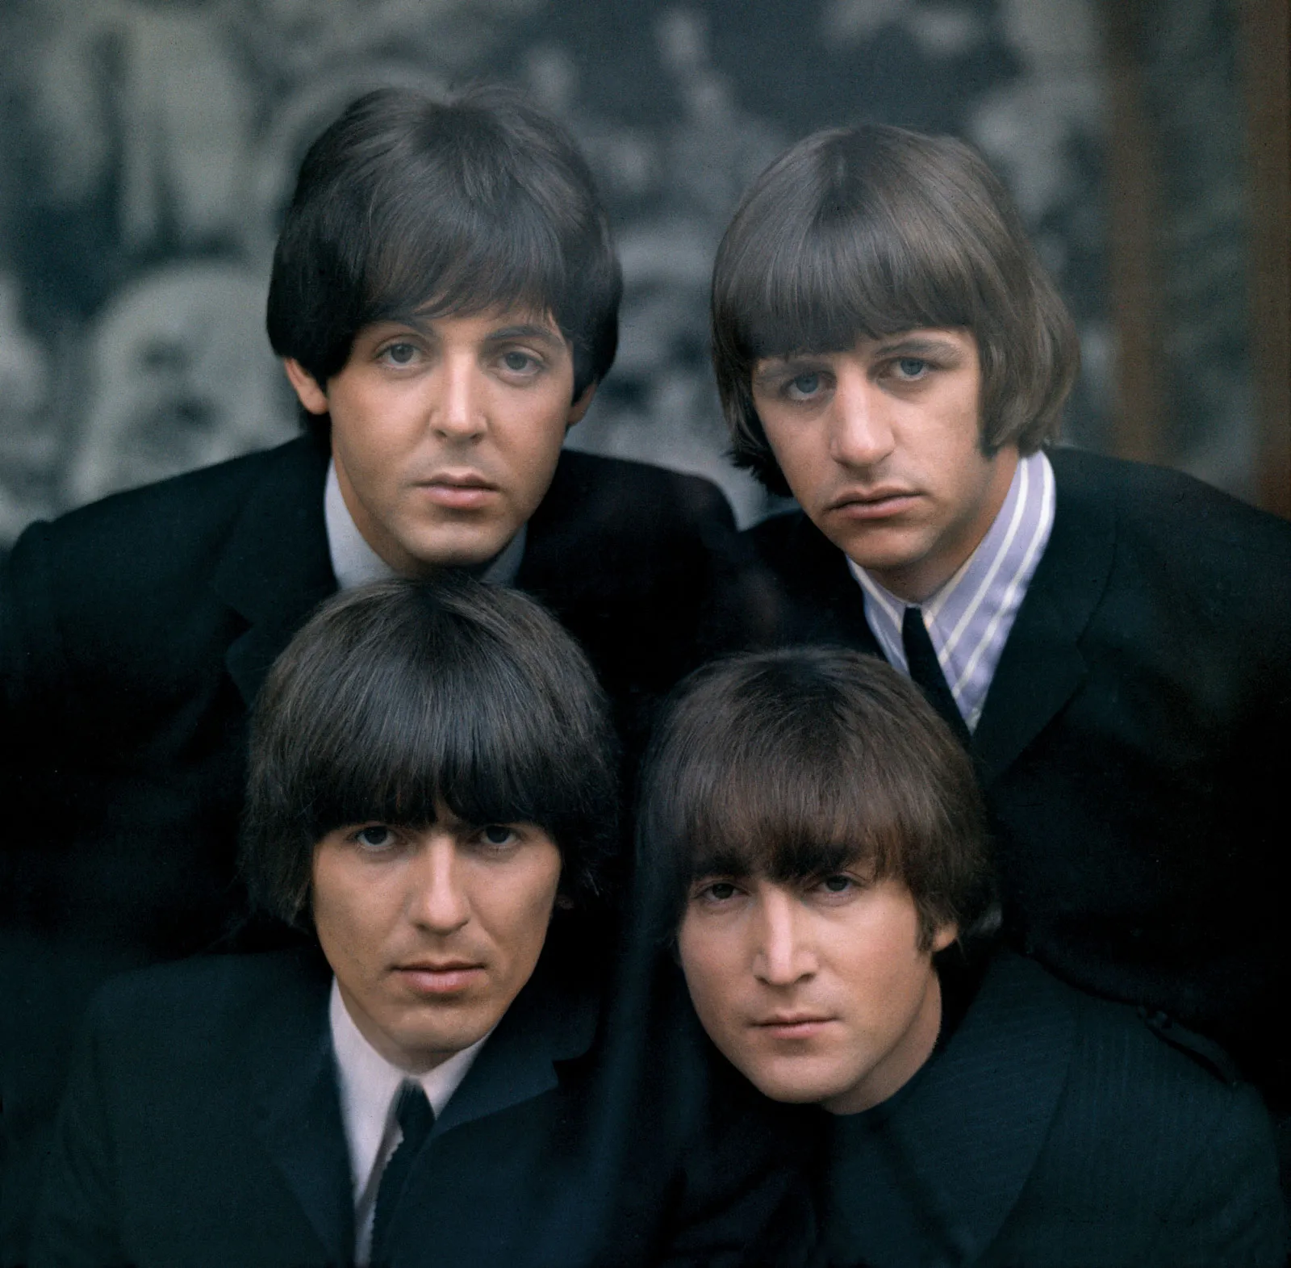

**The Night Before Beatmas**

by Riley Kolan with assistance from James Snyder

Twas the night before Beatmas, where the Beatles sleep.

Dreaming of Christmas and many other things.

John, Paul, George, and Ringo slept in their beds.

Dreaming about guitars and drums Mal Evans could buy them.

George dreamt about guitars, Paul dreamt about new shoes.

Ringo dreamt about new drumsticks. John dreamt about baboons?

Suddenly, the boy heard a noise that was coming from downstairs.

They were a bit frightened, but they got prepared.

They got their protection and tiptoed down the stairs.

To see who or WHAT was down there.

They jumped out into action, with weapons and ALL!

But,the person making all this racket was SANTA CLAUS!

The four boys were in shock, a bit embarrassed.

“You kinda interrupted our sleep”, John said.

“We thought you were an intruder or some sort”,

said the youngest of the band, George.

“Do not fear my boys”, said the big man in red.

“For you all are on the nice list”, he said.

Santa whisked the boys away on their “Magical Mystery Tour”.

To see Santa’s workshop filled with toys galore.

But after the tour, they went back home.

And is where this is the end of this poem.

But before I go, here’s something for you…

This is Johnny Rhythm saying goodbye to you all, and god bless ya’s.

**Teacher’s Favorite Christmas Presents as a Kid**

**by: Brendan Gormley**



**6th Grade:**

**Mrs. Forsyth: Easy Bake oven**

**Mrs. Reagan: 10 Speed Bike**

**Mr. Baia: Simon Memory Game**

**Mr. Neumann: Cap guns**

**Mrs. Wass: A puppy**

**Mr. Baker: Boxing Gloves**

**Dr. Condino: A dollhouse**

**7th Grade:**

**Ms. Henzel: Handmade Barbie Dreamhouse**

**Mr. Moberg: R2d2 night light**

**Mrs. Salvatore: Boombox**

**Mrs. Alessi: Cabbage Patch doll**

**Mrs. McCarthy: Big Fire Truck**

**Mrs. Zeller: New bicycle**

**8th Grade:**

**Mr. Alderman: Gi Joes with kung fu grip**

**Mrs. Aloisio: Easy Bake Oven**

**Mr. Friedrich: Playstation**

**Mrs. Flynt: A white stuffed kitty that looks real (Noelle: I still have her)**

**Mr. Bovanizer: Gameboy**

# CANDY CANE RICE KRISPIES TREATS

# 

(Adapted by My Frugal Adventures)

by Brendan Gormley

Prep time: 5 mins cook time:

Total time: 10 mins

Serves: 6

Ingredients:

* 5½ cups marshmallows
* 3 tbl butter
* 4 crushed candy canes
* 6 cups Rice Krispies cereal
* 1 cup white chocolate chips

Instructions:

1. Add 3 tablespoons of butter to a large pot and heat over medium-low on the stove top.
2. Once the butter melts, add 5½ cups of marshmallows to the pot and stir well until they start to melt.
3. Add 6 cups of Rice Krispies cereal, stirring after each cup.
4. Stir well and add in 1 cup of white chocolate chips, they should melt into the mixture quickly.
5. Finally add the crushed candy cane into the pot and stir.
6. Spoon into a buttered 9 x 13” dish and use a spatula to press the Rice Krispies down firmly.
7. (optional) If you want to crush a 5th candy cane, it looks pretty sprinkled on the top of the Rice Krispies. You can do that before they cool or you can sprinkle the candy cane on the top after you have cut them and removed them from the pan.